Statistical inference

Useful probability distributions:

Half-Cauchy distribution:

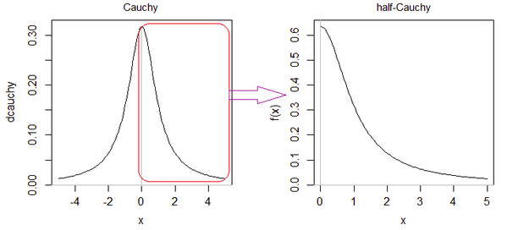

When U and is 2 independent standard normally distributed random variables (of law (N(0,1))

then the ratio U/V has the standard Cauchy distribution. (Wiki)

The standard Cauchy distribution coincides with the [Student's *t*-distribution](https://en.wikipedia.org/wiki/Student%27s_t-distribution) with one degree of freedom. (Wiki)

Student’s t-distribution:

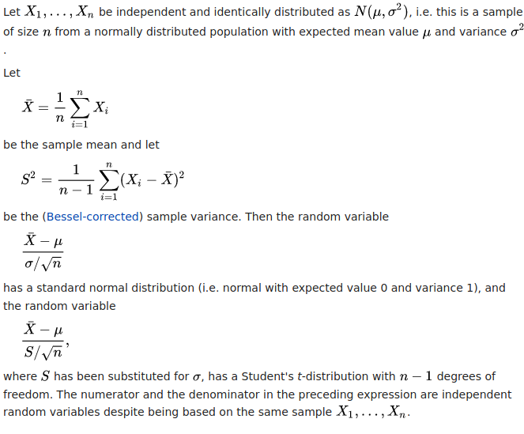

A **log-normal distribution** is a continuous probability distribution of a random variable whose logarithm is normally distributed. Thus, if the random variable X is log-normally distributed, then Y = ln(X) has a normal distribution. (Wiki)

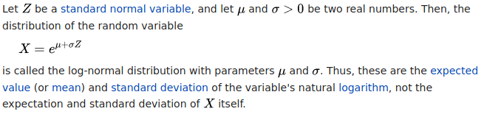

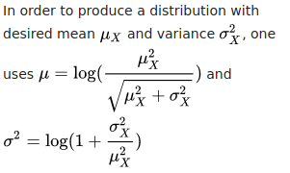

Fit test (Test d’ajustement): see notes pp. 22-24.

Bayesian inference with MCMC sampling

Let X be a rv of law p(mu),

X1, X2, … XN: N-sampling of X

Parameter of interest (mu):

Prior distribution of the parameter of interest

Likelihood distribution of the parameter: observed distribution built from different measures

Posterior distribution of the parameter in the MCMC method: